B.Tech. (Computer Science Engineering)
INT374 – Data Analytics with Power BI



Submitted by: Harsh Singh
Registration Number: 12317841
Roll Number: 67

Submitted to – Dr Ashu Mehta

DECLARATION

I hereby declare that the project titled “Indian Crime Analytics Dashboard (2017–2021)” is an original work carried out by me under the guidance of Dr. Ashu Mehta in partial fulfillment of the requirements for the course Data Analytics with Power BI (INT374) at Lovely Professional University.
This project has not been submitted earlier to any other university or institution for the award of any degree or diploma. All the data sources used in this project have been duly acknowledged, and wherever information has been derived from external sources, proper references have been cited.
I take full responsibility for the authenticity and originality of the work presented in this report.

Name: Harsh Singh
Course: B.Tech in Computer Science & Engineering
Institution: Lovely Professional University

ACKNOWLEDGEMENT

I would like to express my sincere gratitude to Dr. Ashu Mehta, my course instructor and mentor, for his continuous guidance, encouragement, and valuable insights throughout the completion of this project. His expertise in data analytics and Power BI helped me gain a deeper understanding of analytical thinking, KPI design, and dashboard storytelling.
I would also like to thank Lovely Professional University for providing the necessary academic environment and resources to successfully carry out this project as part of the course Data Analytics with Power BI (INT374).
Finally, I am grateful to the Government of India’s Open Data Platform (data.gov.in) for making high-quality public datasets available, which formed the foundation of this analytical study.

Abstract

Crime data analysis plays a crucial role in understanding societal challenges and evaluating the effectiveness of law enforcement systems. This project presents an interactive Power BI dashboard that analyzes Indian crime data from 2017 to 2021, covering both Indian Penal Code (IPC) crimes and Special & Local Laws (SLL) crimes.
The objective of this project is not only to study crime trends but also to evaluate justice system performance through key indicators such as chargesheet rate, pendency percentage, clearance rate, and backlog intensity. By reconstructing these KPIs from raw data instead of relying on pre-calculated values, the dashboard ensures analytical accuracy and reliability.
The project emphasizes crime composition analysis and social impact, with a focused examination of crimes against women and children, alongside a comparative analysis of IPC and SLL cases. Advanced visuals such as funnels, scatter plots, heatmaps, and trend charts are used to identify systemic bottlenecks and investigation stress zones.
This dashboard serves as a decision-support tool, demonstrating how data analytics and visualization can be applied to public policy and governance domains.

Introduction

Crime is a critical social indicator that reflects the safety, stability, and governance of a nation. With the increasing availability of public datasets, data analytics provides an opportunity to move beyond descriptive crime statistics and toward insight-driven evaluation of justice systems.
India’s crime data, published annually by the National Crime Records Bureau (NCRB), offers detailed information on reported crimes, investigations, and police disposals under both IPC and SLL frameworks. However, raw tabular datasets often fail to communicate meaningful patterns, trends, or systemic inefficiencies.
This project leverages Power BI to transform raw crime datasets into a structured analytical model, enabling:
- Temporal trend analysis
- Crime composition assessment
- Social impact evaluation
- Justice system performance measurement
By combining data modeling, KPI engineering, and visual storytelling, the project aims to bridge the gap between crime reporting and actionable insights.

Objectives

The primary objectives of this project are:
- To analyze year-wise crime trends in India from 2017 to 2021
- To study crime composition across IPC and SLL categories
- To evaluate the social impact of crimes, with emphasis on women- and children-related offences
- To compare IPC vs SLL crime patterns and outcomes
- To recalculate and analyze justice system KPIs such as chargesheet rate, pendency percentage, and clearance rate
- To identify case backlog and investigation pressure across years
- To detect systemic bottlenecks using funnel and scatter-based analysis
- To design an interactive dashboard that supports policy-oriented decision making
- To demonstrate practical application of Power BI, DAX, and data modeling techniques
- To enhance analytical storytelling skills using real-world public data

Dataset Description & Sources

Dataset Description
The datasets used in this project consist of crime head–wise police disposal statistics published by the Government of India through its official open data portal data.gov.in. These datasets are compiled annually by the National Crime Records Bureau (NCRB) and provide structured information on crime reporting, investigation, and disposal under different legal frameworks.
The project uses national-level aggregated data for the years 2017 to 2021, covering:
- Indian Penal Code (IPC) crimes
- Special & Local Laws (SLL) crimes
Each dataset includes detailed attributes such as:
- Cases pending from previous years
- Cases reported during the year
- Cases reopened for investigation
- Cases disposed by police
- Cases chargesheeted
- Cases pending at the end of the year
Data Sources
The datasets were obtained from the following official sources:
- IPC Crime Datasets:
https://www.data.gov.in/moreresult/crime%20headwise%20police%20disposal%20ipc%20crime%20cases
- SLL Crime Datasets:
https://www.data.gov.in/moreresult/crime%20headwise%20police%20disposal%20sll%20crime%20cases
These sources ensure:
Authenticity
Government-backed reliability
Consistency across multiple years

DATA COLLECTION & SCOPE

Data Collection Process
The data was collected manually from the data.gov.in portal in CSV/Excel format for each year from 2017 to 2021. Separate datasets were downloaded for IPC crimes and SLL crimes to maintain legal clarity and analytical separation.
The following steps were followed during data collection:
- Identification of relevant crime head–wise disposal datasets
- Verification of schema consistency across years
- Downloading yearly datasets individually
- Organizing datasets by year and law type (IPC / SLL)
Scope of the Study
- National-level analysis
- Time period: 2017–2021
- Legal coverage: IPC and Special & Local Laws
- Focus on investigation and disposal stages
Out of Scope
- State-wise or district-wise analysis
- Court-level outcomes such as convictions or acquittals
- FIR-level or individual case records
This scope ensures clarity and avoids misinterpretation of police disposal data as judicial outcomes.
DATA CLEANING & PREPROCESSING

Data Cleaning Challenges
The raw datasets presented several preprocessing challenges:
- Inconsistent column naming across years
- Redundant and derived columns already present in raw data
- Mixed granularity of crime heads (individual crimes vs totals)
- Inconsistent formatting of crime head labels
Preprocessing Steps
To address these issues, the following transformations were performed:
- Standardized column names across all datasets
- Removed pre-calculated fields to avoid analytical bias
- Created consistent numeric fields for aggregation
- Normalized crime head text for uniform categorization
- Added derived attributes such as:
- crime_type
- law_type (IPC / SLL)
- year
Recalculation of Metrics

Rationale for KPI Recalculation
Although the source datasets included percentage-based metrics, all performance indicators were recalculated using DAX to:
- Avoid dependency on pre-aggregated values
- Ensure consistency across IPC and SLL datasets
- Enable dynamic recalculation under slicer context

Key Calculated Metrics

1. Chargesheet Rate
Measures investigation quality.
$$\text{Chargesheet Rate}=\frac{\text{Chargesheeted Cases}}{\text{Disposed Cases}}$$
Interpretation:
Higher values indicate stronger prosecution readiness.

2. Pendency Percentage
Measures unresolved case burden.
$$\text{Pendency}=\frac{\text{Cases Pending at End}}{\text{Total Cases Investigated}}$$
Interpretation:
Higher pendency reflects systemic backlog.

3. Clearance Rate
Measures system capacity relative to workload.
$$\text{Clearance Rate}=\frac{\text{Cases Disposed}}{\text{Total Cases Investigated}}$$
Interpretation:
- < 1 → backlog accumulation
- ≈ 1 → backlog stability
- > 1 → backlog reduction

4. Backlog Intensity Index
Measures backlog pressure relative to disposal capacity.
$$\text{Backlog Intensity}=\frac{\text{Pending Cases}}{\text{Disposed Cases}}$$
Interpretation:
Higher values indicate operational stress.

5. Year-on-Year (YoY) Growth
Measures crime growth trend.
$$\text{YoY Growth}=\frac{\text{Current Year Crimes - Previous Year Crimes}}{\text{Previous Year Crimes}}$$

6. New Case Inflow
Measures fresh workload entering the system.
$$\text{New Inflow}=\text{Reported Cases}+\text{Reopened Cases}$$

7. Backlog Change
Tracks backlog evolution.
$$\text{Backlog Change}={\text{Pending}}_{end}-{\text{Pending}}_{previous}$$

8. Crime Share (%)
Used in composition analysis.
$$\text{Crime Share}=\frac{\text{Crime Type Cases}}{\text{Total Crimes}}$$
DATA MODELING & FACT TABLE DESIGN

Data Modeling Approach
A single unified fact table named fact_crime was created to support efficient analysis and visualization.
This table consolidates:
- IPC and SLL crime records
- Data across all five years
- Recomputed investigation and disposal metrics
Fact Table Structure
The fact_crime table contains the following attributes:

Identification & Classification Attributes
- crime_head – Specific crime category or legal act
- crime_type – High-level crime classification (Violent, Property, Economic, Crime Against Women, etc.)
- law_type – Legal framework (IPC / SLL)
- year – Reporting year

Case Flow & Investigation Attributes
- pending_prev – Cases pending from previous year
- reported_total – Cases reported during the year
- reopened – Cases reopened for investigation
- total_investigation – Total cases taken up for investigation

Investigation Outcome Attributes
- not_investigated – Cases not investigated under Section 157(1)(b) CrPC
- transferred – Cases transferred to other states or agencies
- withdrawn – Cases withdrawn during investigation

Final Report Attributes
- fr_non_cognizable – Non-cognizable cases
- fr_false – False cases
- fr_mistake_civil – Mistake of fact / civil dispute
- fr_untraced – Untraced or insufficient evidence cases
- fr_abated – Abated cases
- fr_total – Total final report cases

Chargesheet & Disposal Attributes
- chargesheet_prev – Chargesheets from previous year cases
- chargesheet_total – Total chargesheets submitted
- disposal_total – Total cases disposed by police

Pending & Status Attributes
- quashed – Cases quashed during investigation
- stayed – Cases stayed during investigation
- pending_end – Cases pending at end of year
This structure supports:
- Time-based analysis
- Crime-type comparison
- Law-type benchmarking
Modeling Rationale
A flat fact table was chosen over a star schema to:
- Reduce model complexity
- Avoid unnecessary joins
- Improve performance for national-level aggregation
This approach is suitable given the absence of external dimension tables such as geography or demographics.

NATIONAL CRIME OVERVIEW (2017–2021)
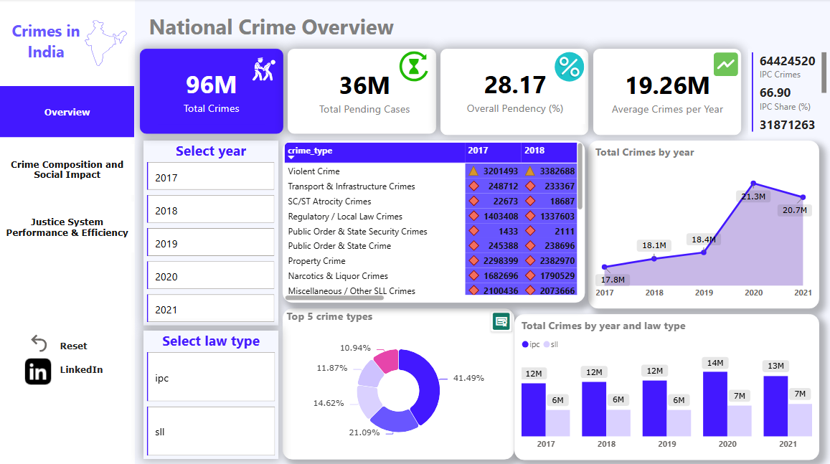

Objective of the Page
The National Crime Overview page presents a high-level summary of crime trends in India from 2017 to 2021, covering both IPC and SLL crimes.
The primary objective is to provide decision-makers with an instant snapshot of crime volume, backlog, pendency, and structural composition before drilling into social impact and justice system performance.

KPI Summary and Interpretation

1. Total Crimes (96 Million)
This KPI represents the total number of criminal cases investigated across all crime heads, law types (IPC & SLL), and years.
Insight:
The magnitude indicates a very high investigative burden on law enforcement agencies at the national level.

2. Total Pending Cases (36 Million)
Displays the cumulative number of cases pending investigation at the end of the respective years.
Insight:
Over one-third of investigated cases remain unresolved, highlighting systemic backlog challenges.

3. Overall Pendency (%) – 28.17%
Calculated as:
$$\text{Overall Pendency}=\frac{\text{Pending Cases}}{\text{Total Crimes}}×100$$
Insight:
A pendency rate close to 30% suggests that case inflow consistently exceeds disposal capacity.

4. Average Crimes per Year (19.26 Million)
Represents the mean annual crime load over five years.
Insight:
This metric normalizes crime volume, allowing year-wise comparisons without bias from outlier years.

5. IPC Crime Share (%) – 66.9%
Indicates the proportion of crimes registered under IPC laws.
Insight:
IPC crimes dominate India’s criminal landscape, emphasizing the continued relevance of core penal laws despite the rise of special legislations.

Filters and User Interactivity

Year Slicer (2017–2021)
Allows users to isolate crime patterns for individual years.

Law Type Slicer (IPC / SLL)
Enables comparative analysis between:
- Penal law crimes (IPC)
- Regulatory & special law crimes (SLL)
Analytical Benefit:
These slicers ensure context-aware KPIs and visuals, making the dashboard dynamic and exploratory.

Visual Analysis

A. Line Chart – Total Crimes by Year
Description:
Plots total crimes from 2017 to 2021.
Observed Trend:
- Gradual increase from 2017–2019
- Sharp spike in 2020 (~21.3M)
- Slight decline in 2021
Insight:
The 2020 surge may reflect exceptional socio-economic conditions, reporting changes, or enforcement variations, making it a structural break year.

B. Stacked Column Chart – Total Crimes by Year and Law Type
Description:
Compares IPC vs SLL crimes year-wise.
Insight:
- IPC crimes remain consistently higher
- SLL crimes show steady growth, reflecting increasing enforcement of regulatory and special laws
This suggests a broadening scope of criminal regulation beyond traditional IPC offences.

C. Donut Chart – Top 5 Crime Types Contribution
Description:
Displays the percentage share of major crime categories, with Violent Crime contributing the largest share (~41.5%).
Insight:
Violent crimes remain the most dominant category, highlighting significant social and public safety concerns.

D. Matrix Table – Crime Type vs Year
Description:
Shows year-wise crime counts across:
- Violent Crime
- Property Crime
- Narcotics & Liquor Crimes
- SC/ST Atrocity Crimes
- Public Order & State Security Crimes
Insight:
- Violent and Property crimes consistently record high volumes
- Certain categories show year-specific spikes, requiring targeted policy responses

Key Insights
- India faces a very high annual crime load with persistent backlog
- IPC crimes continue to dominate, but SLL crimes are structurally important
- 2020 stands out as a critical anomaly year
- Crime composition is not uniform, demanding category-specific interventions

Significance
This page establishes the macro context for the dashboard by answering:
“How large is the crime problem in India, and how has it evolved over time?”
It sets the analytical foundation for:
- Page 2: Crime Composition & Social Impact
- Page 3: Justice System Performance & Efficiency

CRIME COMPOSITION & SOCIAL IMPACT
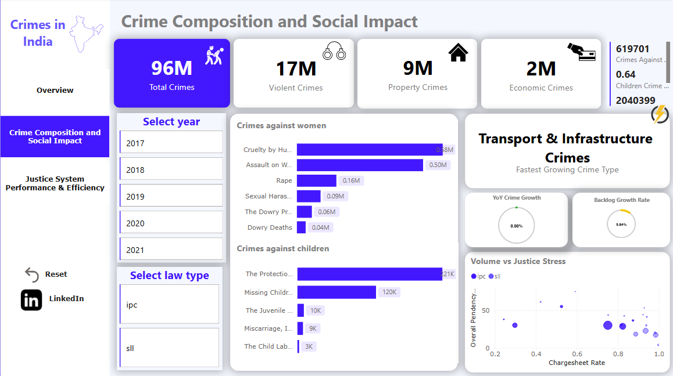

Objective
The Crime Composition and Social Impact page focuses on understanding the nature of crimes, their distribution across categories, and their impact on vulnerable social groups, particularly women and children.
Unlike the overview page, which emphasizes volume and trends, this page answers:
“What kinds of crimes dominate the system, and who is most affected?”

KPI Summary and Interpretation

1. Total Crimes (96 Million)
Represents the overall crime burden across all categories.
Purpose:
Acts as a baseline reference for composition analysis.

2. Violent Crimes (17 Million)
Includes offences affecting the human body such as murder, hurt, rape, kidnapping, etc.
Insight:
Violent crimes constitute a substantial share of total crimes, indicating persistent public safety concerns.

3. Property Crimes (9 Million)
Includes theft, burglary, robbery, dacoity, and related offences.
Insight:
Property-related crimes form the second-largest crime category, reflecting socio-economic stressors.

4. Economic Crimes (2 Million)
Includes fraud, forgery, cheating, counterfeiting, and financial misconduct.
Insight:
Although smaller in volume, economic crimes have high monetary and systemic impact, especially in urban and digital contexts.

5. Crimes Against Women (619,701 cases)
Represents offences targeting women, including domestic violence, sexual assault, harassment, and dowry-related crimes.
Insight:
This KPI highlights the gendered nature of crime and the need for focused policy interventions.

6. Crimes Against Children (204,039 cases)
Includes POCSO, child labour, missing children, and juvenile protection laws.
Insight:
Crimes against children, though lower in absolute numbers, represent high-severity social harm.

Visual Analysis

A. Bar Chart – Crimes Against Women
Description:
Displays major subcategories such as:
- Cruelty by Husband or Relatives
- Assault on Women
- Rape
- Sexual Harassment
- Dowry Deaths
Insight:
Domestic cruelty and assault dominate crimes against women, highlighting that most gender-based crimes occur within familiar or domestic settings, rather than public spaces alone.

B. Bar Chart – Crimes Against Children
Description:
Shows distribution across:
- Protection of Children from Sexual Offences (POCSO)
- Missing Children
- Juvenile Justice violations
- Child labour-related offences
Insight:
POCSO-related offences form the largest share, emphasizing serious child protection gaps.

C. Fastest Growing Crime Type Indicator
Highlighted Category:
Transport & Infrastructure Crimes
Insight:
This category’s rapid growth reflects increasing urbanization, infrastructure expansion, and regulatory enforcement in transport-related domains.

D. KPI Gauges – YoY Crime Growth & Backlog Growth Rate
- YoY Crime Growth: Shows annual rate of change
- Backlog Growth Rate: Indicates accumulation of pending cases
Insight:
Even when crime growth stabilizes, backlog growth can persist, revealing capacity constraints in investigation systems.

E. Scatter Plot – Volume vs Justice Stress
Axes:
- X-axis: Chargesheet Rate
- Y-axis: Overall Pendency
- Size/Color: Law Type (IPC vs SLL)
Insight:
Certain crime categories show high chargesheet rates but also high pendency, proving that investigation quality alone does not guarantee timely justice.
This visual effectively identifies stress zones in the justice system.

Filters and Interactivity
- Year Selector (2017–2021)
- Law Type Selector (IPC / SLL)
Analytical Advantage:
Allows users to observe how crime composition and social impact shift over time and legal framework.

Key Insights
- Violent crimes remain the largest contributor to overall crime
- Crimes against women are dominated by domestic and interpersonal violence
- Child-centric crimes reveal systemic vulnerabilities in protection mechanisms
- Rapid growth in transport-related crimes signals emerging regulatory challenges
- High pendency persists even in high chargesheet environments

Significance
This page deepens the analysis by connecting crime statistics to social consequences, enabling stakeholders to:
- Identify vulnerable populations
- Prioritize high-impact crime categories
- Understand justice stress beyond raw volume

JUSTICE SYSTEM PERFORMANCE & EFFICIENCY
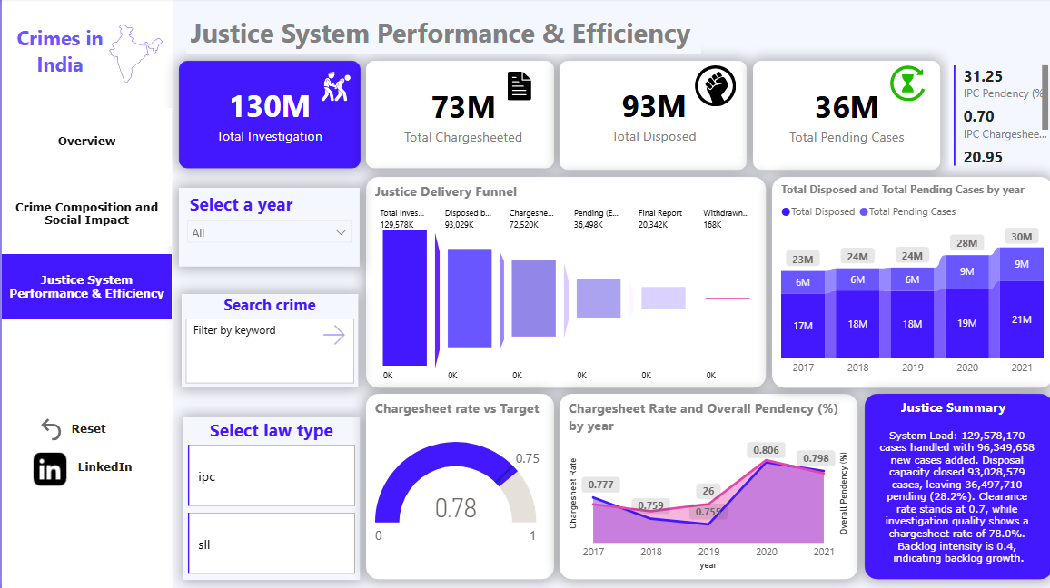

Objective
The Justice System Performance & Efficiency page evaluates how effectively law enforcement agencies handle criminal cases, from investigation to closure.
This page shifts focus from crime occurrence to justice delivery, addressing the question:
“Is the justice system keeping pace with crime?”

KPI Summary and Interpretation

1. Total Cases Investigated (130 Million)
Represents the total workload handled by the police, including new, reopened, and pending cases.
Insight:
This reflects an extremely high systemic load, placing sustained pressure on investigative capacity.

2. Total Chargesheeted Cases (73 Million)
Indicates cases where investigation was completed and prosecution initiated.
Insight:
A substantial portion of cases reach prosecution, suggesting reasonable investigation effectiveness.

3. Total Cases Disposed (93 Million)
Includes all cases concluded through chargesheets, final reports, or withdrawals.
Insight:
Disposal volume is high, but does not fully offset incoming case volume.

4. Total Pending Cases (36 Million)
Represents unresolved cases at the end of the period.
Insight:
Persistent pendency highlights structural backlog, not merely year-specific inefficiencies.

5. IPC Pendency (%) – 31.25%
Shows backlog severity specifically under IPC laws.
Insight:
IPC crimes experience higher pendency, likely due to complexity and volume.

6. IPC Chargesheet Rate (%) – ~70%
Measures prosecution readiness under IPC.
Insight:
While investigation quality is reasonable, pendency remains high—indicating capacity rather than quality constraints.

Visual Analysis

A. Justice Delivery Funnel
Stages Visualized:
- Total Cases Investigated
- Cases Disposed
- Chargesheeted Cases
- Pending Cases
- Final Reports
- Withdrawn Cases
Insight:
The funnel reveals progressive attrition, especially between investigation and chargesheeting, exposing critical bottlenecks in case completion.

B. Stacked Column Chart – Disposed vs Pending by Year
Description:
Compares year-wise disposed and pending cases.
Insight:
Despite rising disposals, pending cases also grow—indicating that case inflow consistently outpaces resolution.

C. Gauge Chart – Chargesheet Rate vs Target
Observed Value: ~0.78
Target Threshold: 0.75
Insight:
Investigation quality meets and slightly exceeds benchmark levels, reinforcing that pendency is not due to poor investigation alone.

D. Line Chart – Chargesheet Rate & Pendency Trend
Description:
Dual-axis line chart showing:
- Chargesheet rate (left axis)
- Overall pendency (right axis)
Insight:
Years with improved chargesheet rates do not always show proportional pendency reduction, underscoring system-wide capacity limitations.

E. Justice Summary Narrative Card
Key Observations Highlighted:
- System load: ~129.6M cases
- Disposal capacity: ~93M cases
- Pending backlog: ~36.5M cases
- Average pendency: ~28%
- Backlog intensity index: ~0.4
Insight:
This narrative consolidates complex metrics into a policy-oriented summary, enabling quick executive interpretation.

Filters and Interactivity
- Year Selector (All / Individual Years)
- Law Type Selector (IPC / SLL)
- Search Crime (Keyword-based)
Analytical Benefit:
Allows granular investigation of specific crime heads and legal frameworks, making the dashboard operational as well as strategic.

Key Insights
- High chargesheet rates do not automatically reduce backlog
- IPC crimes experience greater pendency pressure than SLL crimes
- Disposal capacity is improving, but not fast enough to offset inflow
- Backlog is systemic, not episodic

Significance
This page completes the analytical journey by evaluating justice delivery effectiveness, making the dashboard not just descriptive, but diagnostic.
It enables stakeholders to:
- Identify justice bottlenecks
- Assess investigation quality
- Understand backlog dynamics
- Support data-driven policy decisions

OVERALL FINDINGS & KEY INSIGHTS

Summary of Analytical Findings
Based on the comprehensive analysis of IPC and SLL crime data (2017–2021), several key findings emerge across crime trends, social impact, and justice system efficiency.

1. Persistent High Crime Load
- India records an average of ~19 million crimes per year
- Total investigated cases exceed 130 million
- Crime inflow remains consistently high across all years
Indicates structural pressure on law enforcement capacity

2. Crime Composition is Skewed Towards Violence & Property
- Violent crimes contribute the largest share (~41%)
- Property crimes form the second largest category
- Economic crimes, though lower in volume, have high systemic impact
Crime prevention strategies must be category-specific

3. Crimes Against Women & Children Remain Structurally Significant
- Domestic cruelty and assault dominate crimes against women
- POCSO and missing children cases dominate crimes against children
- These crimes persist irrespective of overall crime trends
Highlights the need for targeted social and legal interventions

4. Regulatory & SLL Crimes Are Increasing
- Transport, infrastructure, narcotics, and regulatory crimes show growth
- SLL crimes demonstrate better chargesheet efficiency
- Reflects expanding regulatory enforcement in India

5. Justice System Faces Chronic Backlog
- Over 36 million cases remain pending
- Pendency rate ~28%
- IPC crimes show higher pendency than SLL crimes
Backlog is systemic, not year-specific

Strategic Insights
- High chargesheet rate ≠ low pendency
- Investigation quality exists, but capacity constraints dominate
- Backlog growth indicates need for systemic reform rather than incremental fixes

SOCIAL IMPACT ASSESSMENT

Impact on Vulnerable Groups

Crimes Against Women
- Dominated by domestic violence and interpersonal abuse
- Indicates deep-rooted societal challenges
- Requires legal + social reform synergy

Crimes Against Children
- POCSO cases are most prominent
- Child protection remains a critical governance issue
- Reporting has increased, but resolution remains slow

Public Safety & Urban Impact
- Rise in transport & infrastructure crimes aligns with urban expansion
- Indicates need for better regulatory oversight
- Reflects complexity of modern urban crime

Justice Stress Zones
- Certain crime types show high pendency and high volume
- Scatter and heatmap analysis identifies systemic stress points
- Enables prioritization of judicial and investigative reforms

Policy Implications
- Strengthening fast-track courts for women & children
- Digitization of investigation workflows
- Resource reallocation based on crime type intensity

LIMITATIONS OF THE STUDY

Data-Level Limitations
- Aggregated national data
- No state-wise or district-wise granularity
- Does not include conviction outcomes

Analytical Limitations
- Pendency reflects police investigation stage only
- Judicial delays beyond chargesheeting are not captured
- External factors (pandemic, law changes) not explicitly modeled

Visualization Constraints
- Some advanced visuals rely on custom Power BI visuals
- Interpretation depends on slicer context
- KPI sensitivity to filters requires careful usage

Scope Constraints
- Limited to IPC & SLL crimes
- Cybercrime depth limited due to aggregation
- No demographic profiling available

SCOPE FOR IMPROVEMENT & FUTURE WORK

Data Expansion Opportunities
- State-wise and district-wise drilldowns
- Integration with court conviction datasets
- Inclusion of cybercrime and financial loss data

Advanced Analytics Possibilities
- Forecasting crime trends using time-series models
- Predictive backlog modeling
- Crime hotspot detection using spatial analytics

Dashboard Enhancements
- Role-based dashboards (Police, Judiciary, Policy Makers)
- Automated alerts for backlog thresholds
- AI-driven narrative insights

Societal Impact
This dashboard demonstrates how data analytics can support governance, enhance justice delivery, and promote evidence-based policy decisions.

CONCLUSION

This project successfully demonstrates the use of data analytics and visualization techniques to analyze national-level crime data in India using Power BI. By integrating IPC and SLL crime datasets from 2017 to 2021, the dashboard provides a holistic, data-driven view of crime trends, social impact, and justice system performance.
The analysis moves beyond surface-level crime counts and focuses on:
- Crime composition
- Impact on vulnerable groups
- Efficiency of law enforcement
- Systemic backlog and pendency
Through carefully designed KPIs and visuals, the project reveals that:
- Crime volume in India remains consistently high
- Violent and property crimes dominate overall composition
- Crimes against women and children remain a serious social concern
- The justice system shows reasonable investigation quality but struggles with capacity and backlog

Key Learning Outcomes
This project strengthened the following skills and concepts:
- Data cleaning and transformation
- Fact table design without traditional dimensions
- DAX measures for KPIs (YoY growth, pendency, rates)
- Analytical dashboard storytelling
- Social and policy-oriented data interpretation
Overall, the project highlights how data analytics can support governance, justice delivery, and evidence-based policymaking.

PROJECT LINKS & REFERENCES

Dataset Sources (National-Level Data)
All datasets used in this project were sourced from the official Government of India open data portal:
- IPC Crimes Dataset:
https://www.data.gov.in/moreresult/crime%20headwise%20police%20disposal%20ipc%20crime%20cases
- SLL Crimes Dataset:
https://www.data.gov.in/moreresult/crime%20headwise%20police%20disposal%20sll%20crime%20cases
Source Authority:
📌 National Crime Records Bureau (NCRB)
📌 data.gov.in

Project Repository & Dashboard Links
- GitHub Repository:
https://github.com/harxh1405/crime-analytics-dashboard
- LinkedIn Project Post:
https://www.linkedin.com/posts/harsh-singh-35b24336b_powerbi-dataanalytics-crimeanalytics-activity-7408539478111260672-NUez?utm_source=share&utm_medium=member_desktop&rcm=ACoAAFuxojcB822rFm3HrYXexepZrsPFu8Tiurs

These links showcase:
- Dashboard screenshots
- Project explanation
- Key insights and outcomes

Tools & Technologies Used
- Power BI Desktop
- DAX (CALCULATE, DIVIDE, FILTER, YoY logic)
- Data Modeling & Fact Table Design
- Custom Visuals (MAQ Funnel, Gauge, Scatter, Heatmap)
- Microsoft Excel (Preprocessing)

